**Insights for Day 1**

**Accident Type Analysis:**

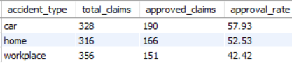

* Car claims: 58% approval → highest, smooth processing.
* Home claims: 53% approval → moderate, may need minor improvements.
* Workplace claims: 42% approval → lowest, potential for process review or fraud detection.

**Age Group Analysis:**

* <25: 34% approval → youngest clients may need guidance.
* 25-40: 56% approval → smooth processing.
* 41-60: 47% approval → moderate approval rate, may need minor review.
* 60: 55% approval → high approval, likely simpler claims.

**Actionable Insights:**

* Improve claim support for younger clients (<25).
* Review Workplace claims for delays or errors.